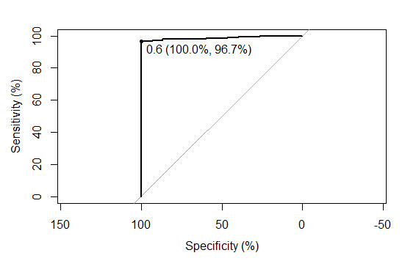

Most relevant values highlighted

threshold 0.634500 <- Cutoff value

specificity 100.000000

sensitivity 96.730245

accuracy 96.858639

tn 15.000000

tp 355.000000

fn 12.000000

fp 0.000000

npv 55.555556

ppv 100.000000

1-specificity 0.000000

1-sensitivity 3.269755

1-accuracy 3.141361

1-npv 44.444444

1-ppv 0.000000

precision 100.000000

recall 96.730245

Area under the curve: 98.65%